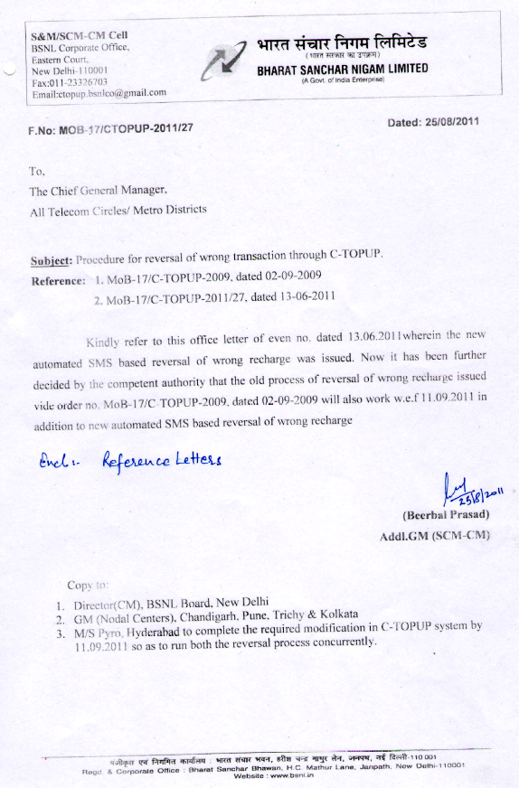

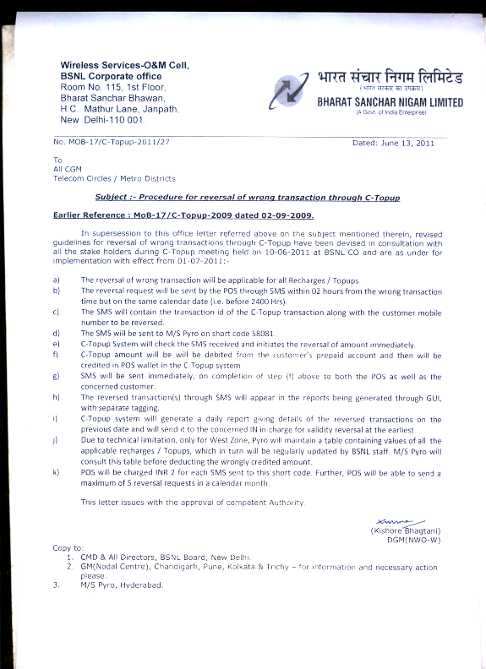

Bharat Sanchar Nigam Limited
(A Government of India Enterprise)
Room-113, Bharat Sanchar Bhawan, Janpath, New Delhi
(Mobility Network Operations Cell)
No. MOB-17/CTOPUP-2009 Dated: 02-9-2009
To-
Chief General Manager,
All Telecom Circles

Sub: Procedure for reversal of wrong transaction through C-Topup

While in the meeting on C-Topup related issues held on 14-7-2009 under chairmanship of Director (CM), some of the franchisees demanded provision for reversal of wrong subscriber transaction executed through C-Topup. In consideration of this requirement, it is to state that currently multiple types of subscriber transactions through C-Topup, namely Recharge, Topup, Validity, Migration and Special pack transactions for reduced rate for specified duration are in use.

2. Validity, Migration & Special pack transactions cannot be reversed due to technical limitations. Similarly, Validity granted through Recharge transaction cannot be reversed. However, talk value reversal for other two types of transactions i.e., Recharge & C-Topup transactions are feasible and following guidelines cum procedure are hereby issued:
- Double check mechanism is already inbuilt in the C-Topup SIM menu to avoid frequent mistakes and hence such requirement is expected to be bare minimum. Also to rule out possibility of mischief by POS to any subscriber, reversal process will be executed & managed only by the SDE/ JTO in-charge of C-Topup/ Sales in the SSA concerned.
- SDE/ JTO in-charge of C-Topup/ Sales in SSA interacts regularly with franchisees/ retailers & other POS and hence POS can convey the transaction ID, MSISDN of POS and also MSISDN of the subscriber for the wrong transaction requiring reversal to the SDE/ JTO.
- Concerned SDE/JTO will advise/ educate the POS for not repeating the mistake frequently by following the checks available in the menu.
- The C-topup vendors will add password protected menu in the GUI of Ctopup system to enable concerned SDE/ JTO to query & confirm available balance with the customer in the prepaid IN system and talk value given to customer through this wrong recharge.
- Based on confirmation, SDE/ JTO will decide the amount to be recovered from the mistaken subscriber. Recovered amount may be less than or equal to the wrong transaction amount depending upon available balance at that moment in the IN system.
- Amount to be credited to the account of POS will be equal to the amount recovered from mistaken subscriber less the amount in lieu of non-recoverable validity.
- Upon successful reversal, the SMS will be sent from the C-Topup system to the POS and concerned subscriber.
This may be brought to the notice of all concerned for implementation with immediate effect.

(A.K. Misra)
AGM (CME)
Copy to-
- CMD & All Directors, BSNL Board, New Delhi
M/s Pyro Hyderabad & M/s Estel, Gur

